HORTICULTURE MANAGEMENT SYSTEM

**NAME : ROCHELLE VAZ**

**ROLL NO. : 1960**

**INTRODUCTION**

Horticulture Management System provides an easy way for the customers to purchase products. At the same time, it reduces the workload of the admin. The admin no longer needs to maintain the user data and the products data manually. He can generate various reports based on the data that’s been collected. The customers will not be able to view all the data that the admin can access. So this also maintains security of the crucial data that the admin may not want to share publicly. Hence, this is termed to be beneficial for both the admin as well as the customers.

**OBJECTIVES**

The main objective of this project is to create an online horticulture store that allows a customer to search and view the various products that are available in the store. It is to also help the admin to manage the products and the various customers of the store and make necessary reports.

**FEATURES**

The interface of this project has been designed completely user-friendly. The customer can purchase the products from anywhere, and at any time.

This project consists of two types of users- Admin and Customer. Admin is the main user of the store. There’s only one login form through which both will have to login using their correct credentials, that is, username, password and user type but both will get different pages based on the user type. Admin will be re-directed to the Admin panel and customer will be re-directed to the User panel.

Admin manages the entire store and generates various reports.

**PROGRAMMING LANGAUGE**

**Design and interface**: HTML, CSS

**Programming Language**: PHP

**Scripting Language**: JavaScript

**Database**: MySQL Server

**ENTITY-RELATIONSHIP DIAGRAM (ERD)**

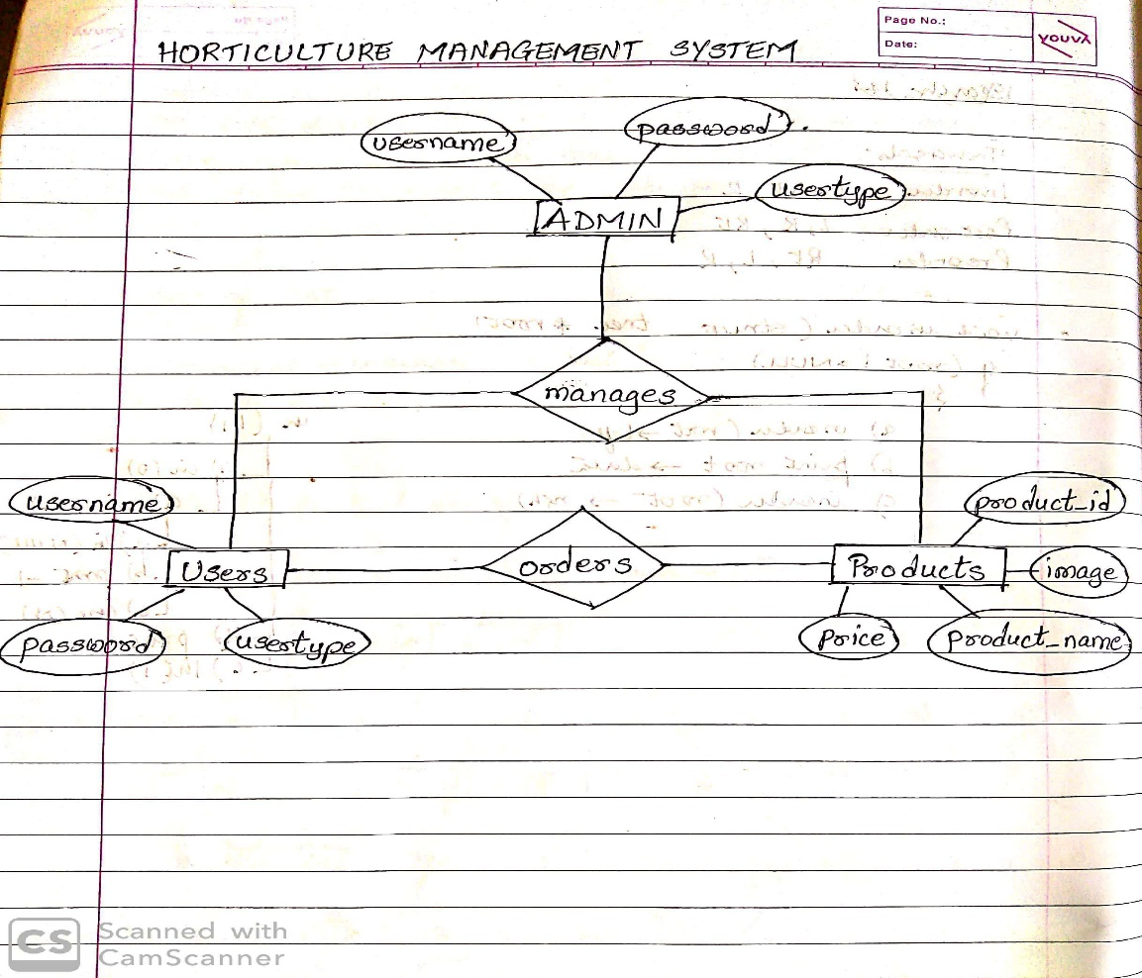

Admin->username(primary key), password, usertype

Users->username(primary key),password, usertype

Products->product_id, image, product_name, price

**USER OF THE SYSTEM**

1. **Admin** : Admin is the one who manages all the information of the store. Admin has full control over the system. He can add, delete, update, search, view all the products of the store and also view all the registered users of the website.
2. **User**: These are the customers who can buy products through online. In order to purchase products a customer needs to get himself registered without which he won’t be able to login into the system. Once registered, he can login and can access the website. He can view and search for products.

**MODULES**

**LOGIN MODULE**

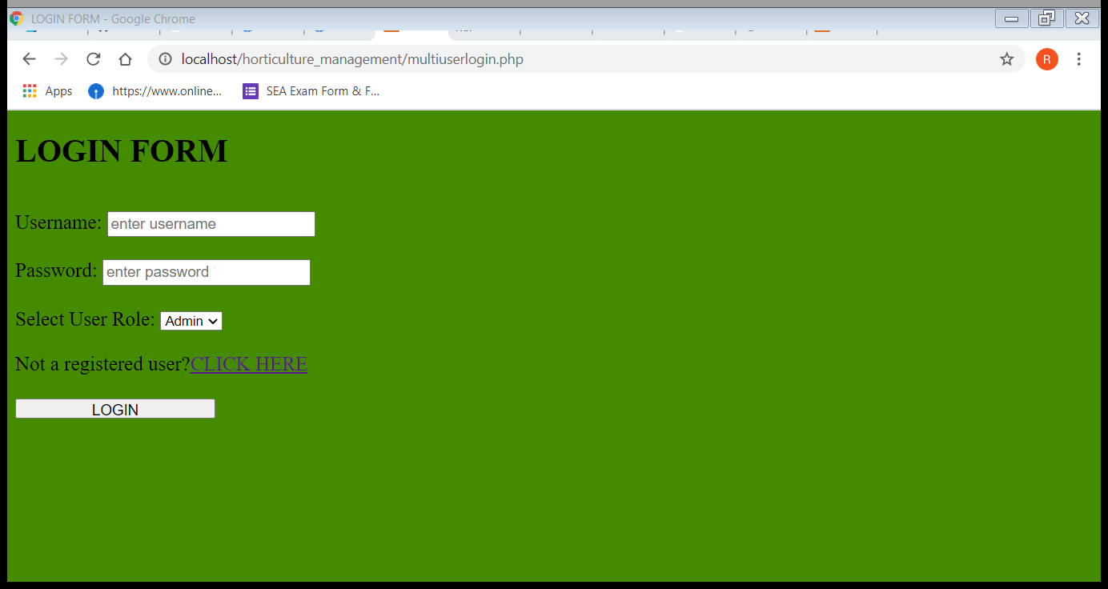

**REGISTRATION MODULE**

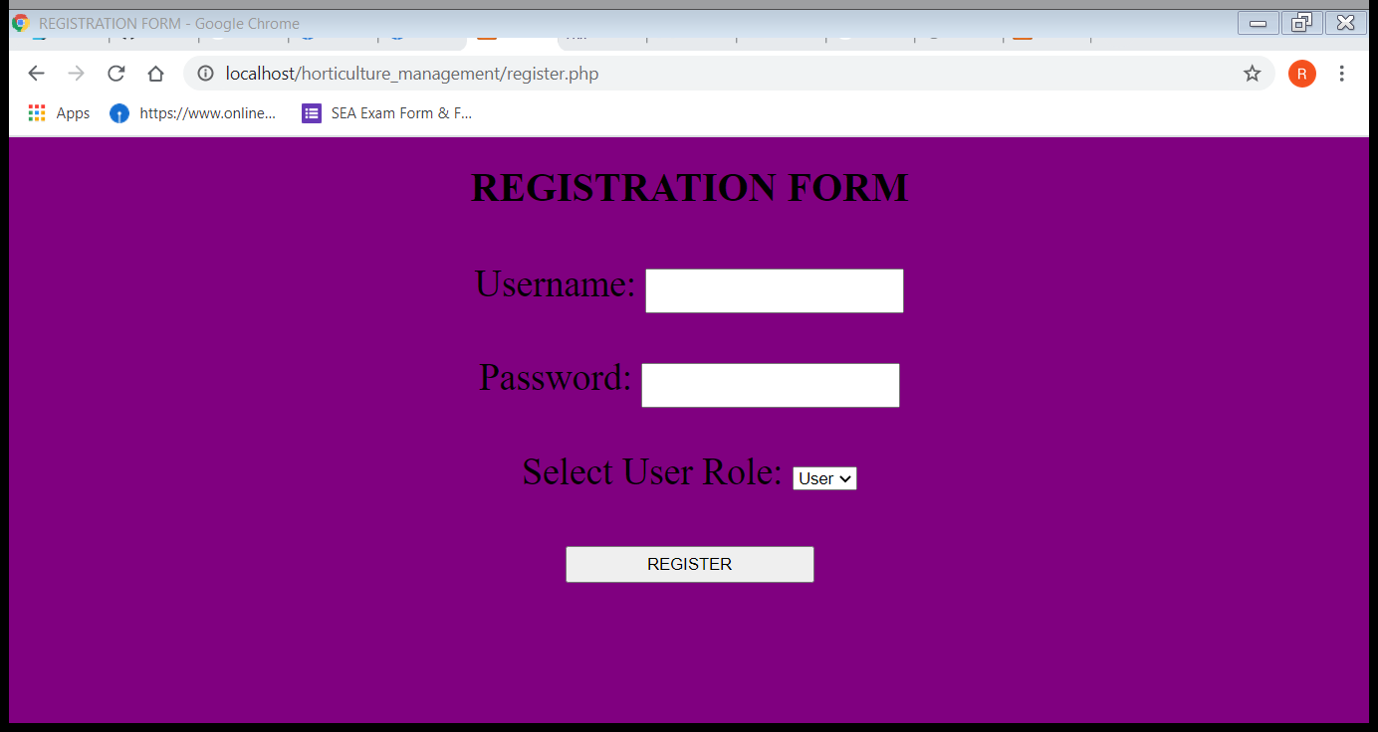

**LOGIN FOR ADMIN**

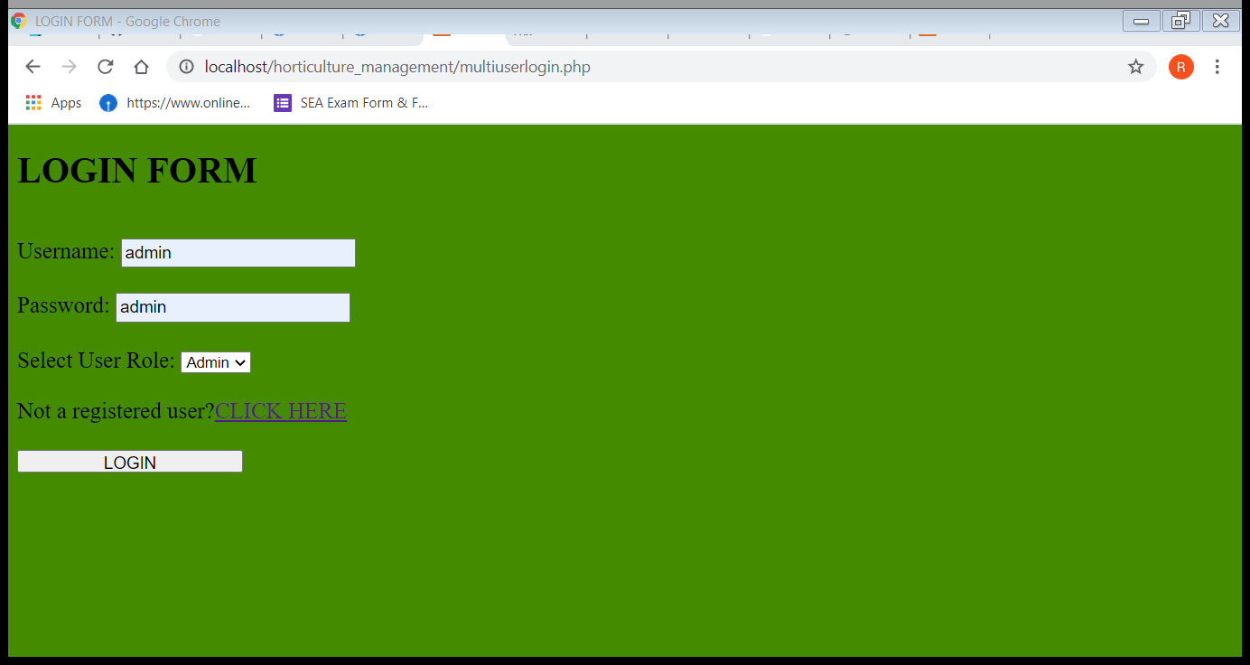

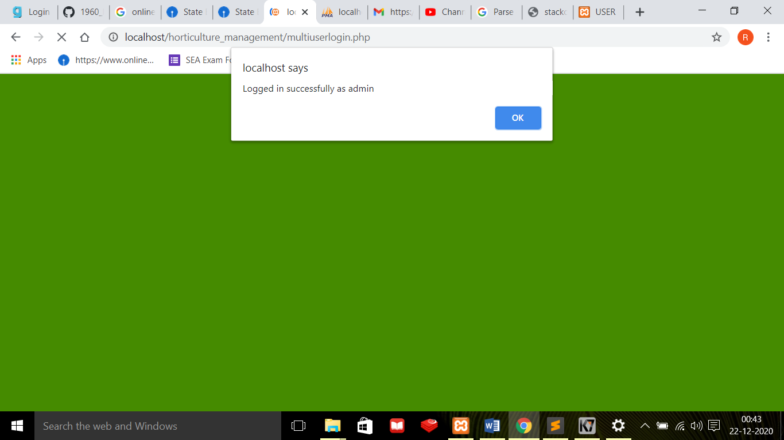

**ADMIN MODULE**

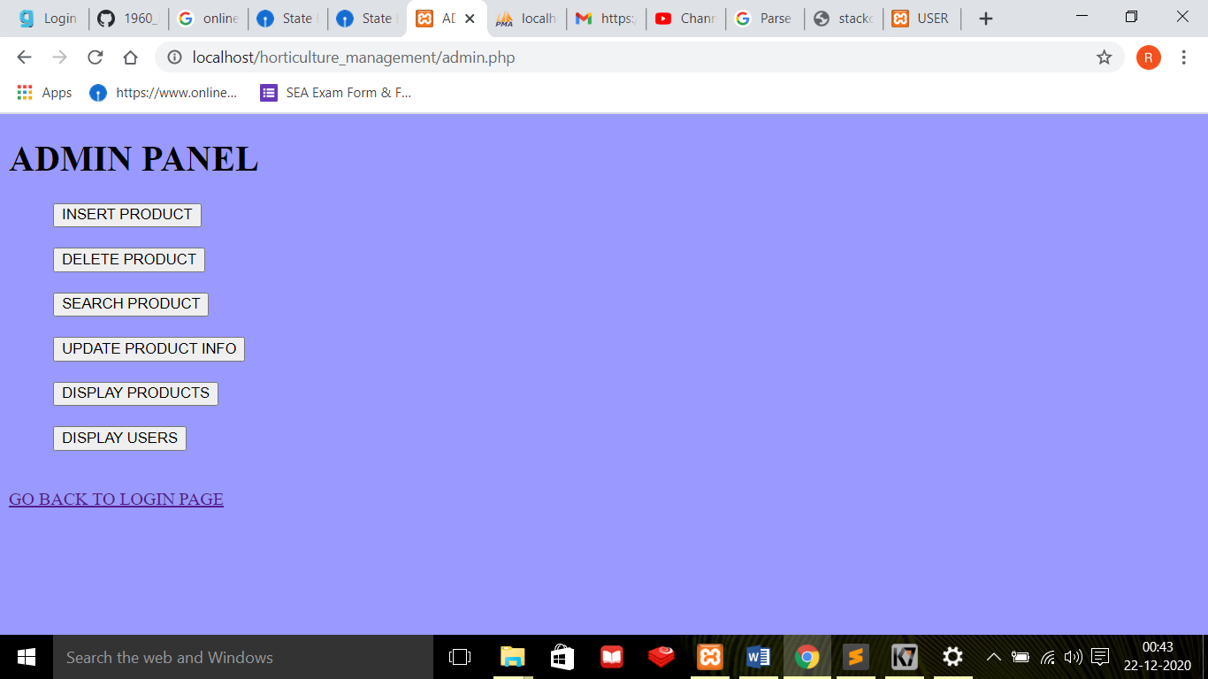

**ADMIN – INSERT PRODUCT MODULE**

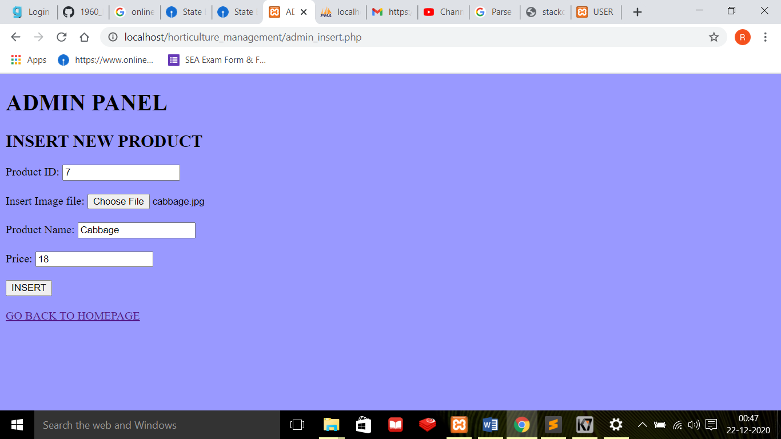

**OUTPUT AFTER INSERTING THE ABOVE PRODUCT**

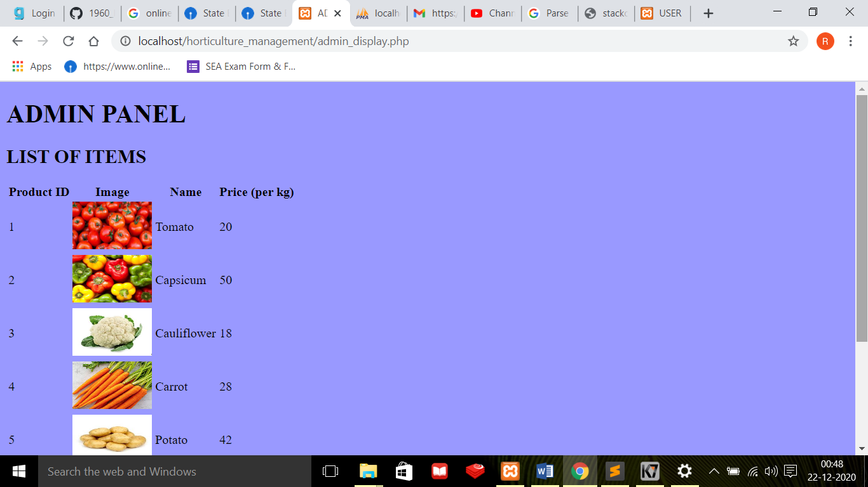

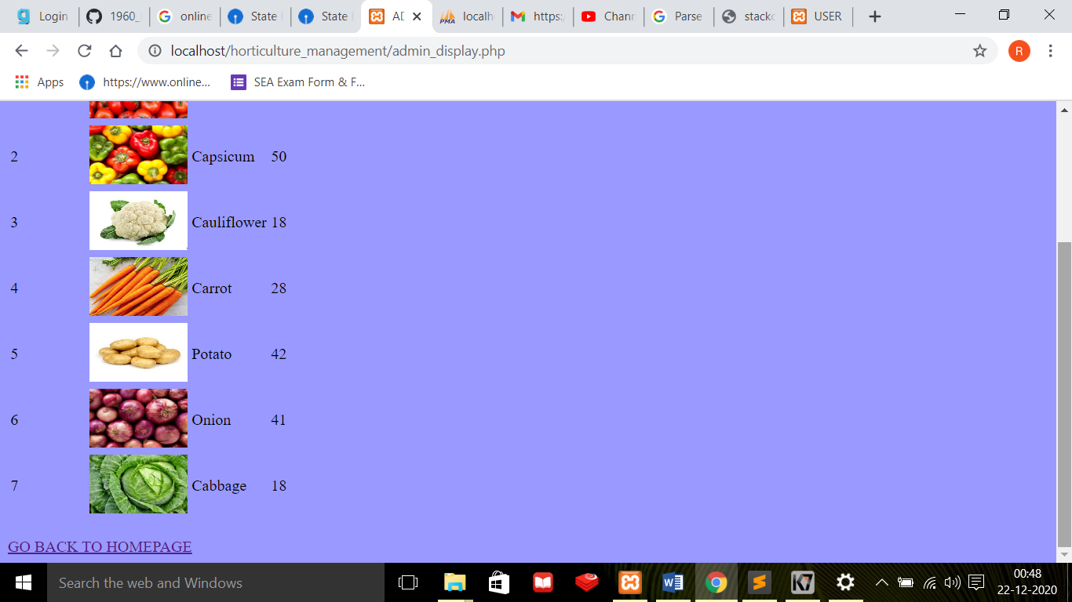

**ADMIN – DELETE PRODUCT MODULE**

**(Deletion based on existing product ID)**

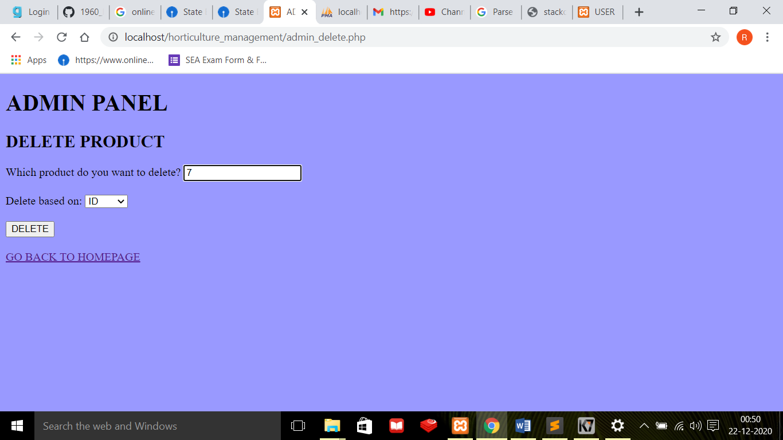

**OUTPUT AFTER DELETING THE ABOVE**

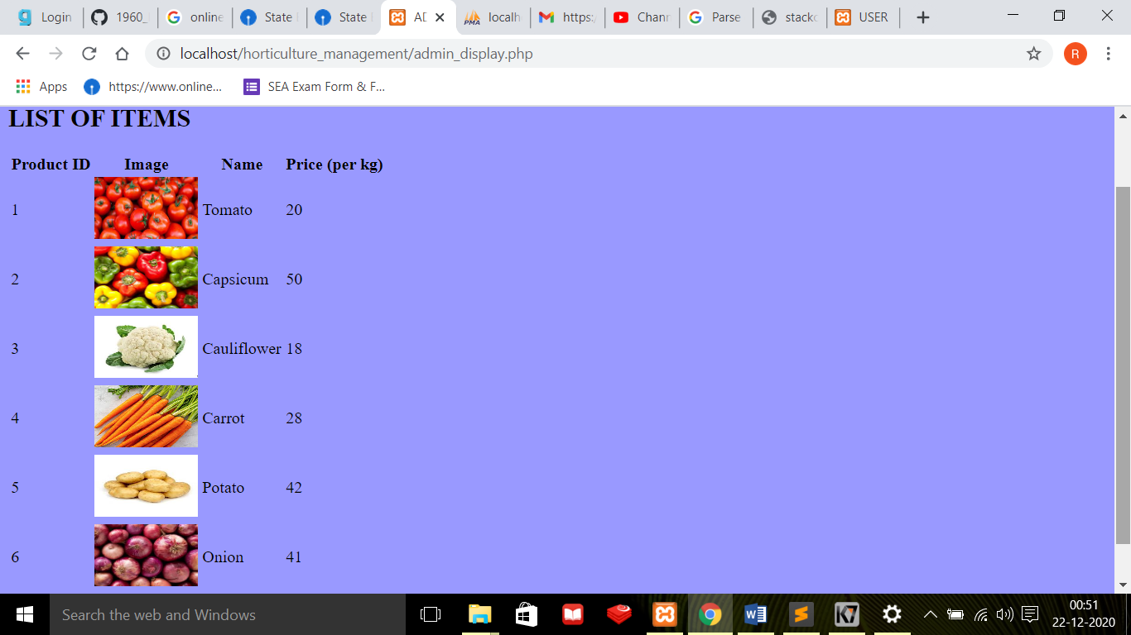

**(Deletion based on dexisting name of the product)**

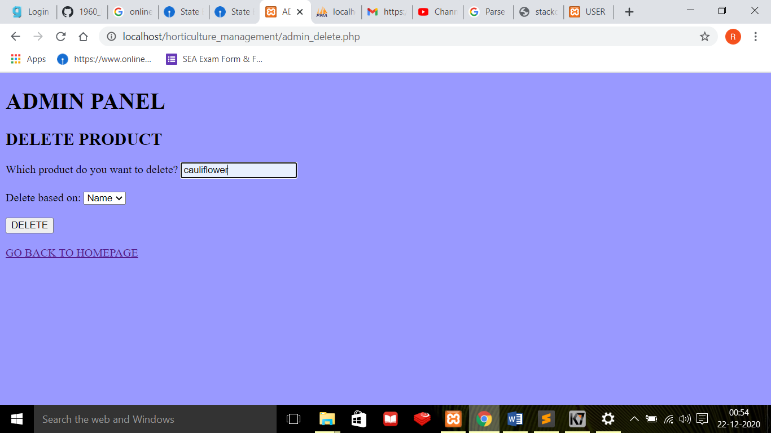

**OUTPUT AFTER DELETING THE ABOVE PRODUCT**

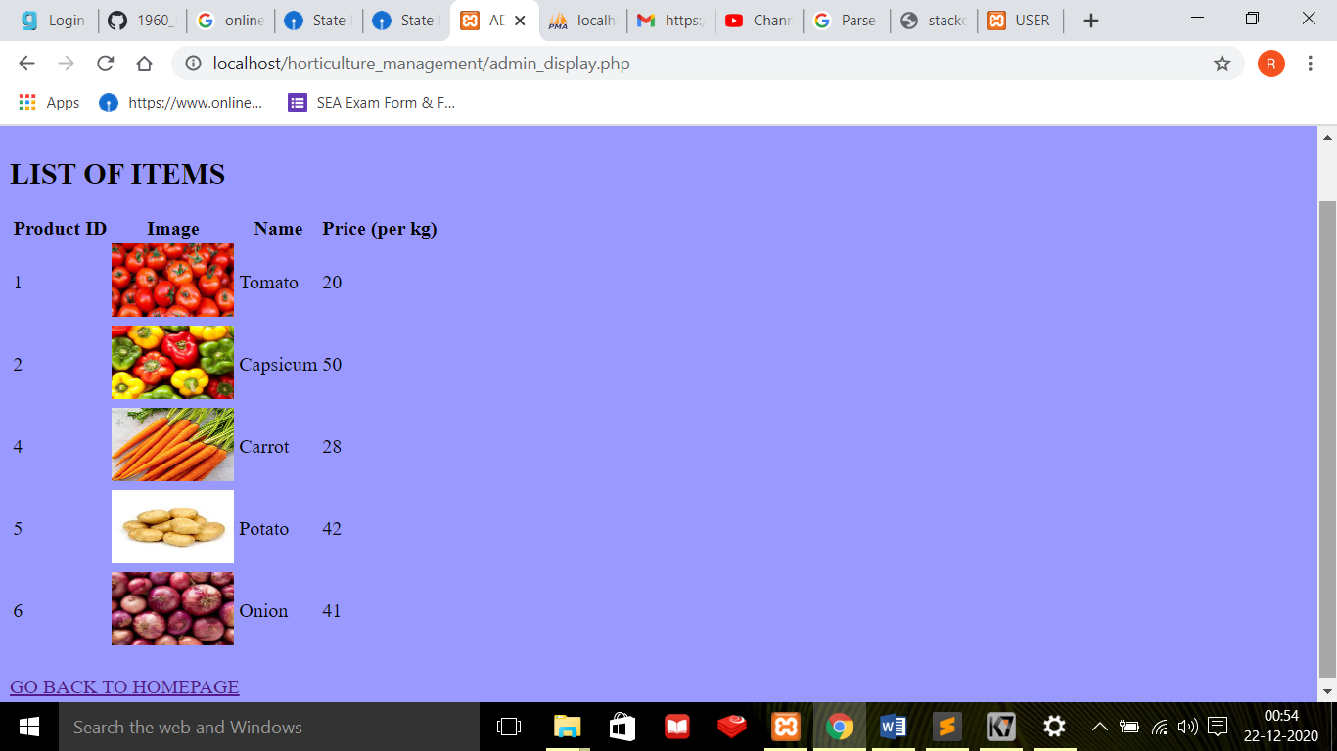

**ADMIN – SEARCH PRODUCT MODULE**

**(Search based on existing product name)**

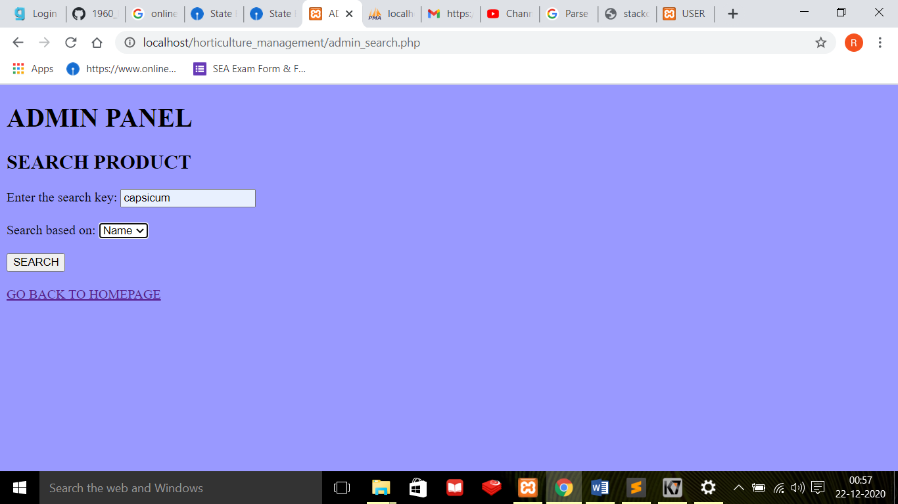

**OUTPUT AFTER SEARCHING FOR THE ABOVE PRODUCT**

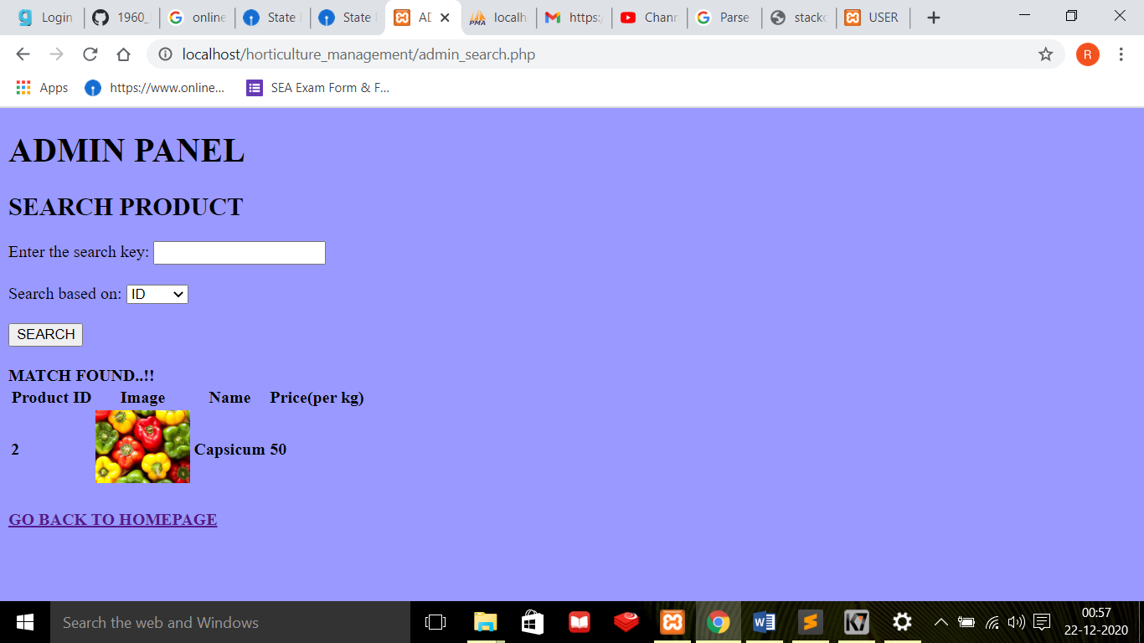

**(Search based on non-existing product id)**

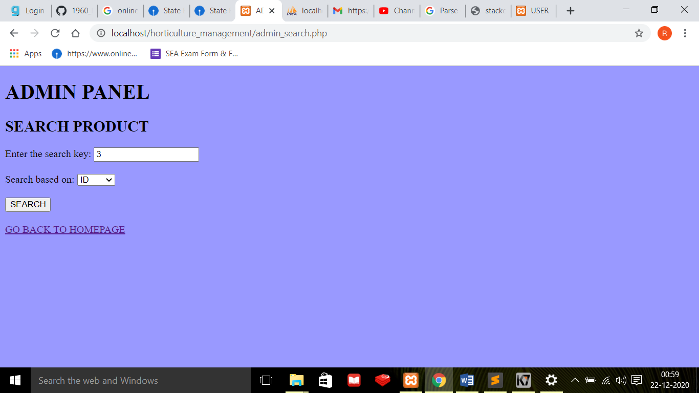

**OUTPUT AFTER SEARCHING FOR THE ABOVE PRODUCT**

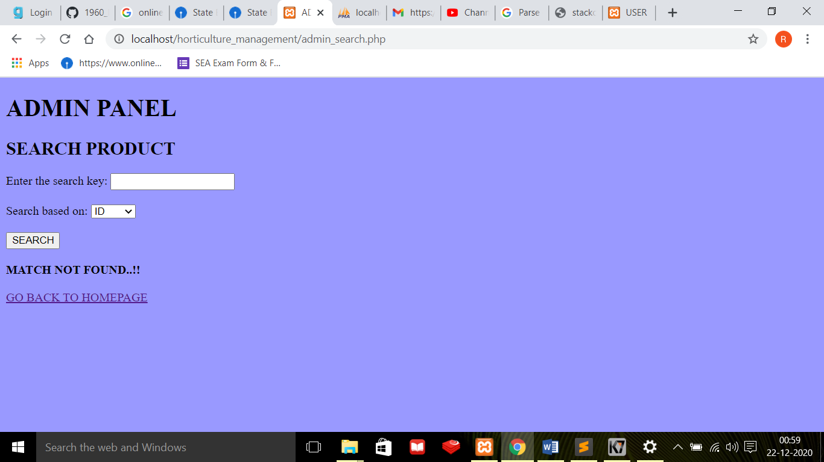

**ADMIN – UPDATE PRODUCT INFO MODULE**

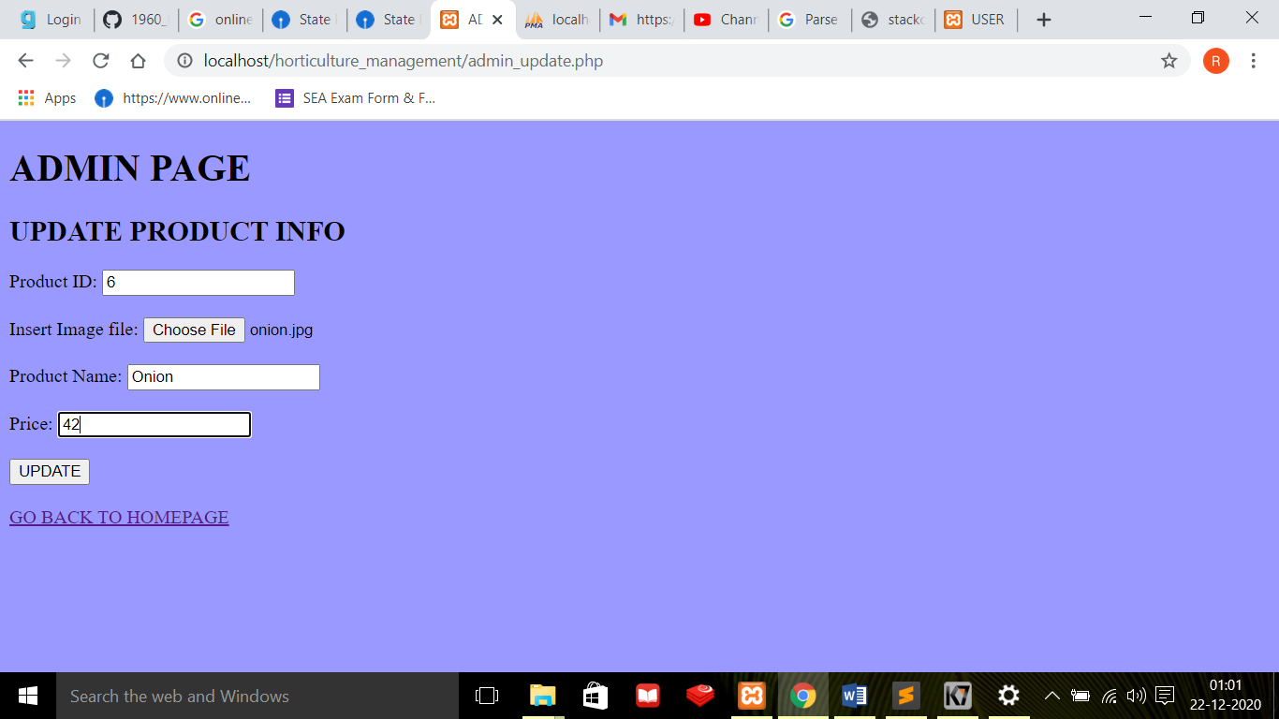

**OUTPUT AFTER UPDATING THE ABOVE PRODUCT INFO**

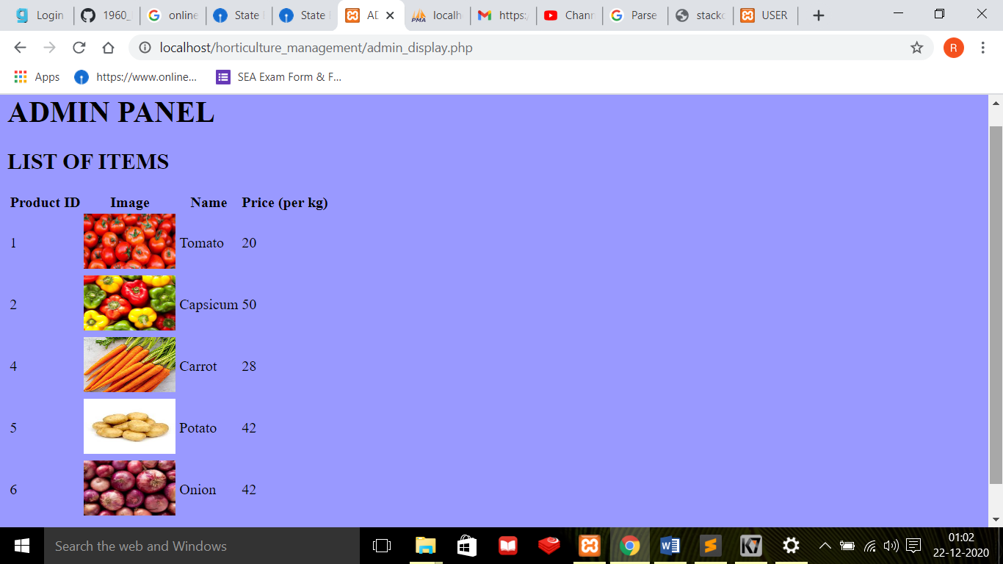

**ADMIN – DISPLAY PRODUCTS MODULE**

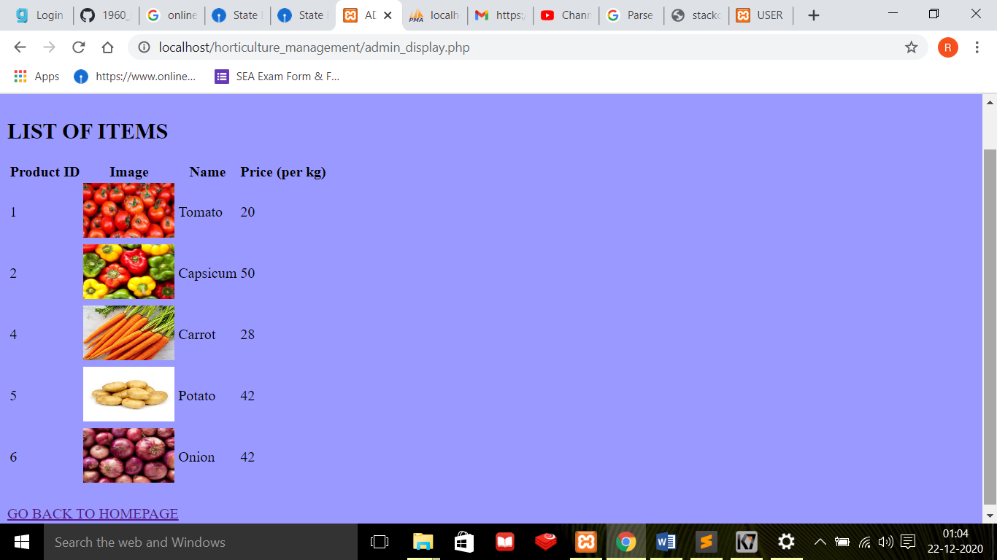

**ADMIN – DISPLAY USERS MODULE**

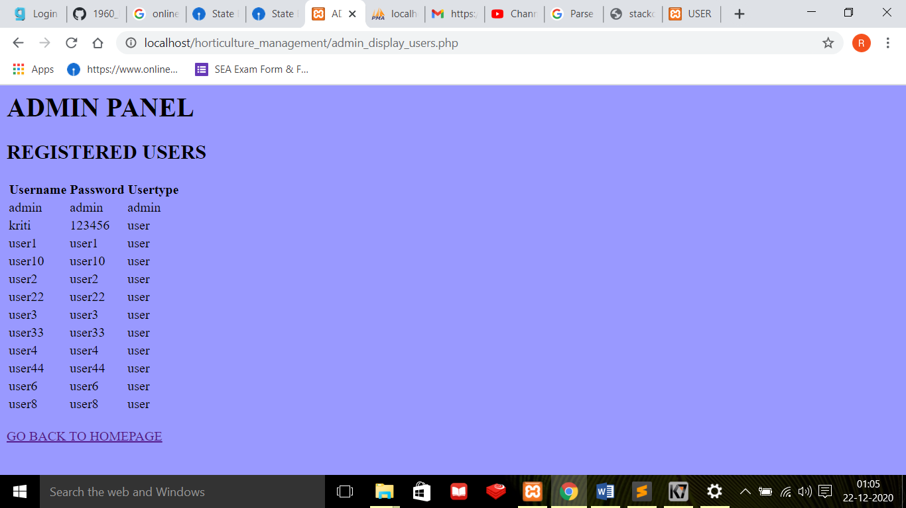

**LOGIN FOR USER**

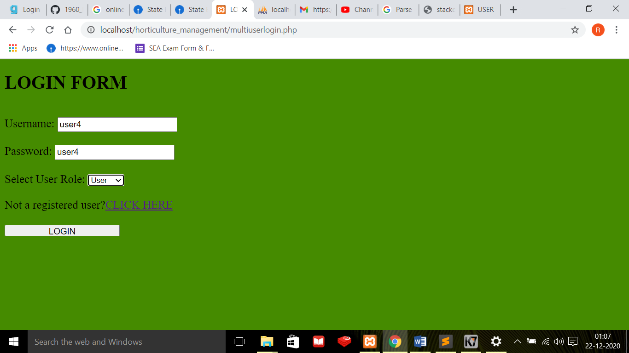

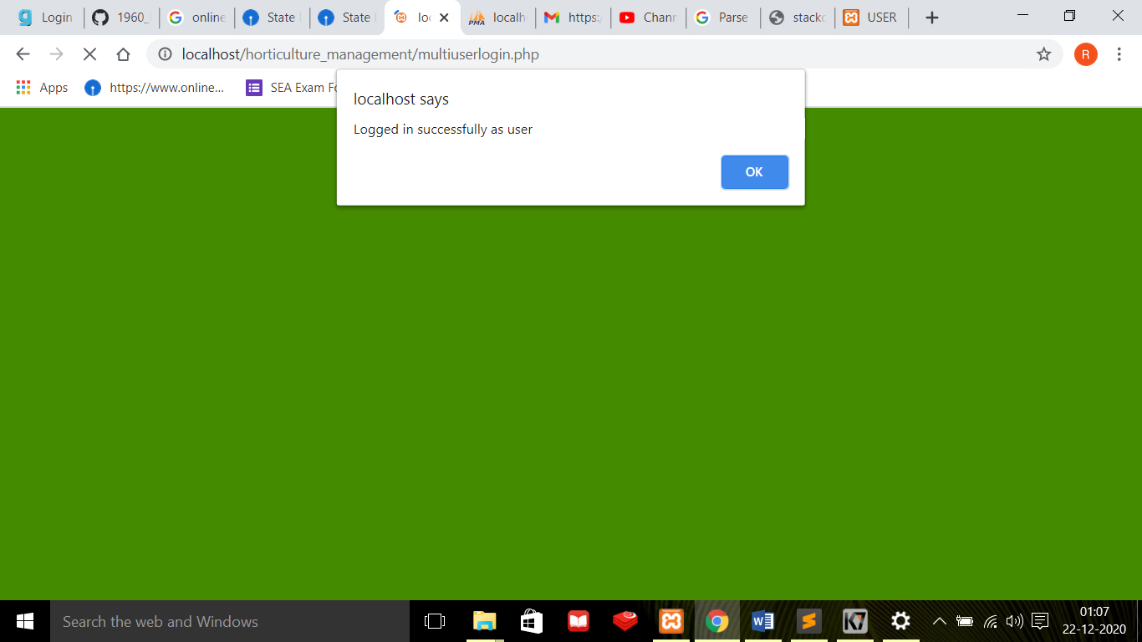

**USER MODULE**

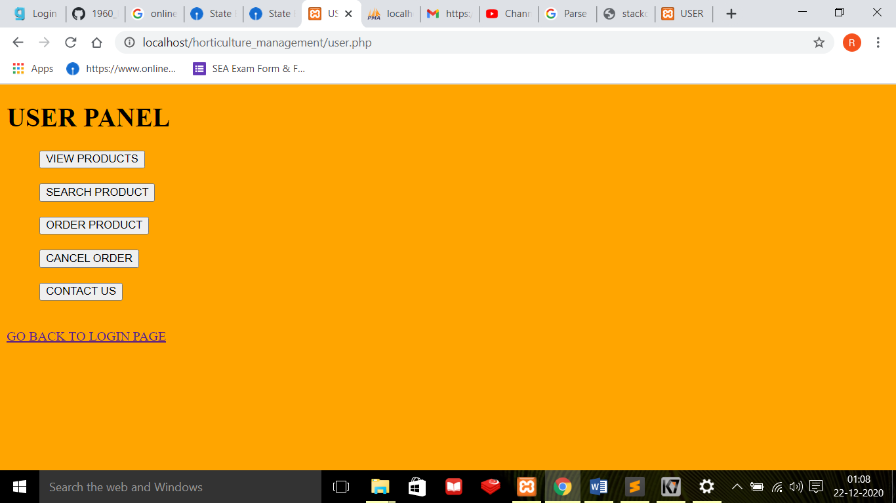

**USER – VIEW PRODUCTS MODULE**

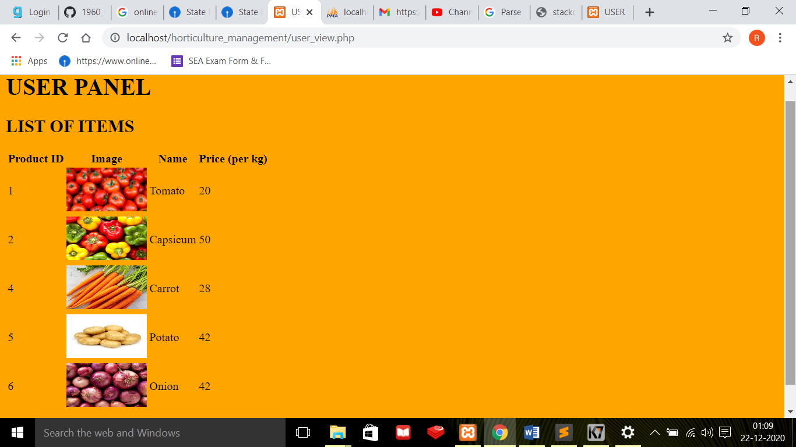

**USER – SEARCH PRODUCT MODULE**

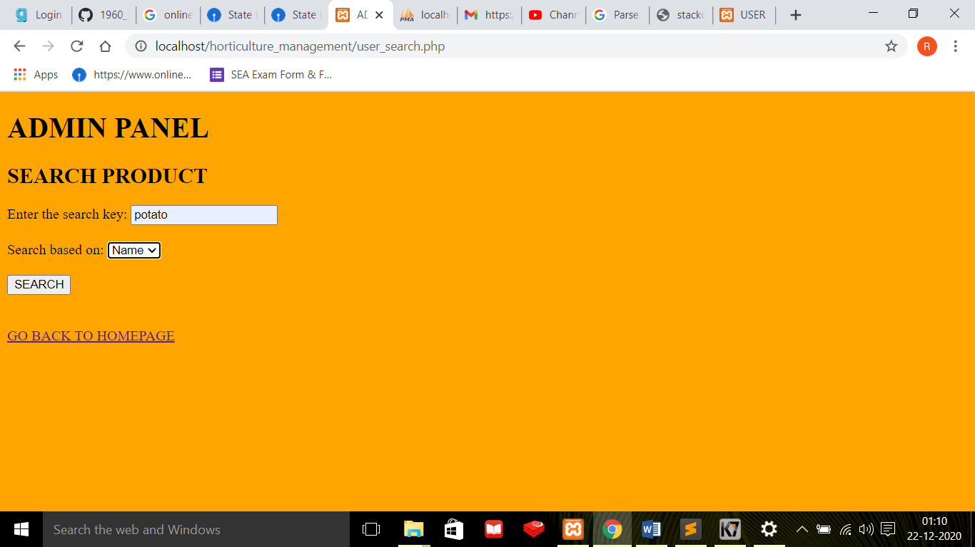

**OUTPUT AFTER SEARCHING FOR THE ABOVE PRODUCT**

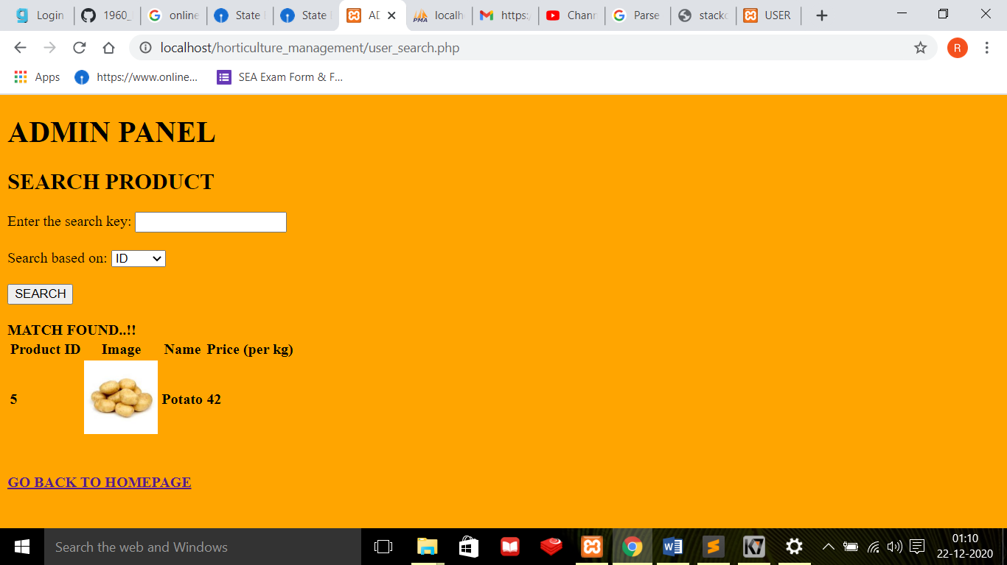

**USER – CONTACT US MODULE**

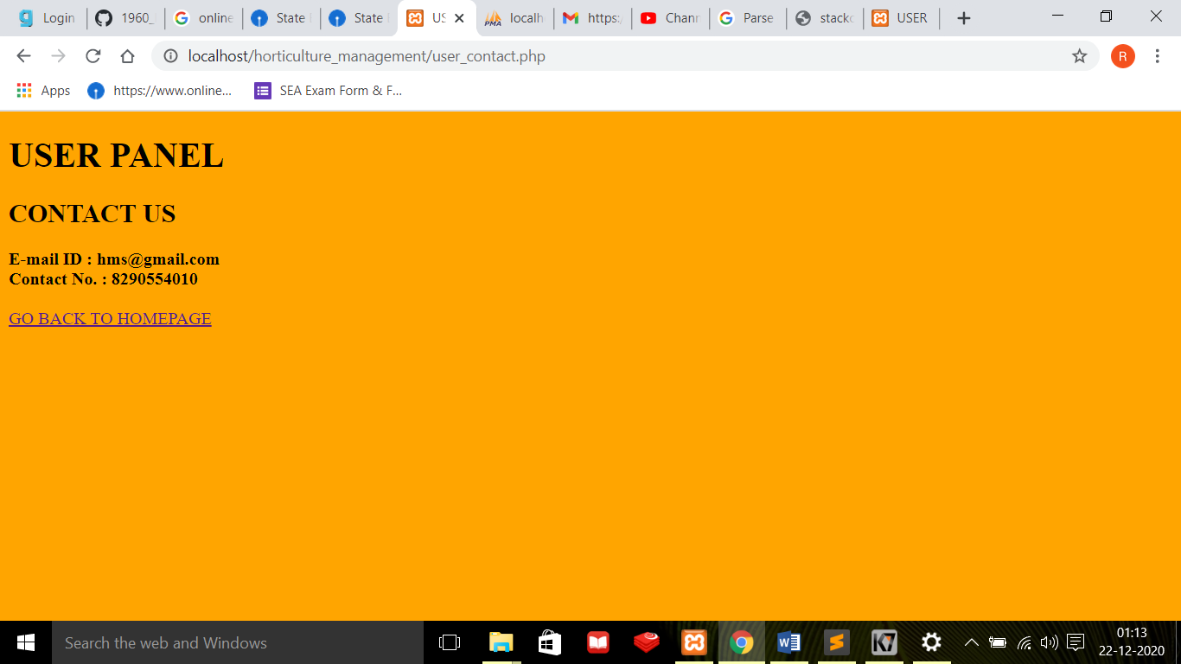

**DATABASE – horticulture_store**

**TABLE1 (products)**

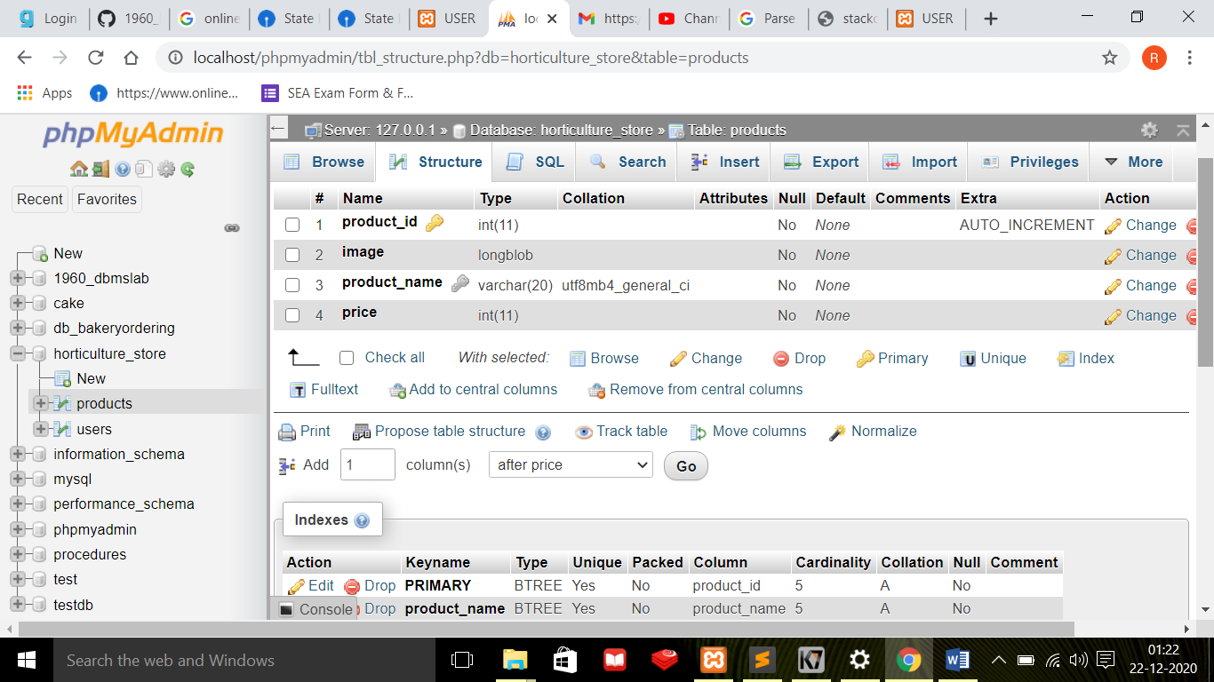

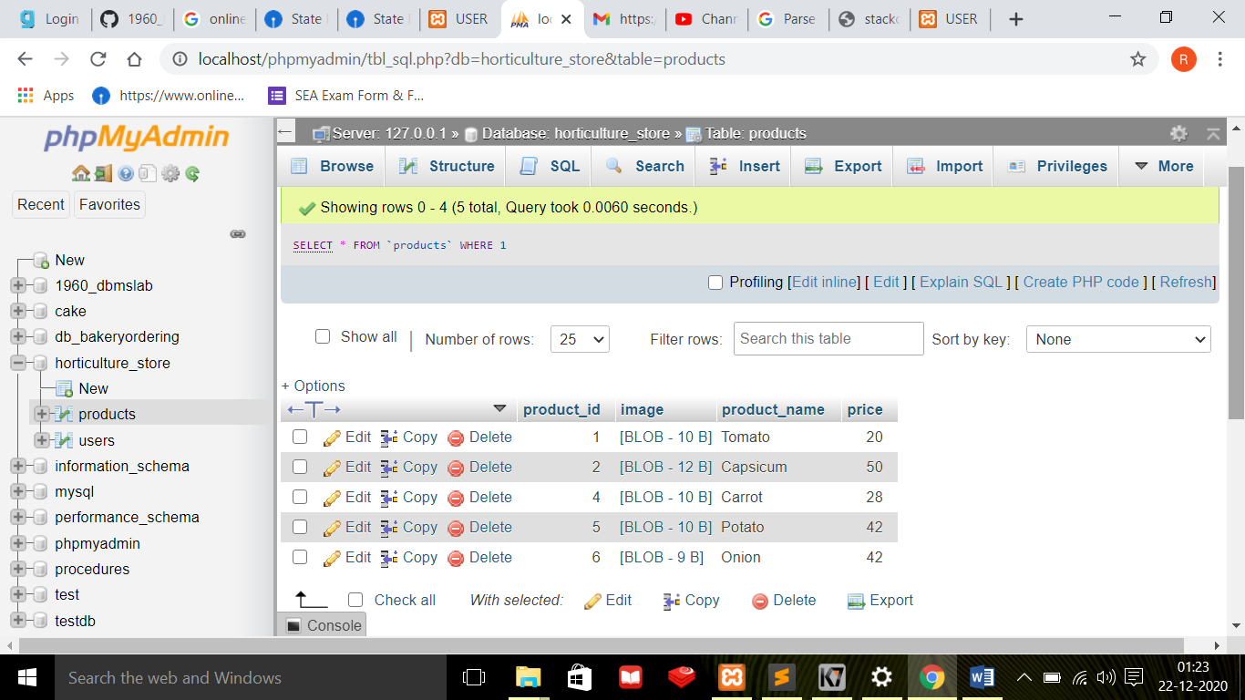

**TABLE2 (users)**

